**A REPORT ON MY STUDY EXPERIENCE FOR THE LAST 3 WEEKS IN AKIRACHIX**

**INTRODUCTION**

I am a part of a team of 52 young ladies who aspire to venture into technology at Akirachix; an institution that offers tech training for the competitive tech world. The experience so far is fascinating and intense at the same time. The units include,

1. Introduction to computers
2. Python
3. JavaScript
4. Mobile Development
5. Graphic design
6. Entrepreneurship
7. Electronics
8. Hardware Design
9. Life Skills
10. HTML $CSS

**INTRODUCTION TO COMPUTERS**



I have to confess that this is the most interesting unit so far, the facilitator taking us through this unit is very friendly and engaging. Here we have been taught how to use Microsoft office, command prompt, how to write emails, how to use Google documents and we have even created GitHub accounts. I am looking forward to more experience.

**1.PYTHON**

At first, the term “Python” to most of us meant a type of a snake which is true, but not in the tech world. Python is a programming language used by programmers to build web applications, desktop applications, artificial intelligence etc.

So far we have learnt about data types which include strings, float and variables.

**2.HTML & CSS**

HTML & CSS is also a type of a programming language and it is also an interesting language to learn. I find it at some point hectic a little bit because once you miss out on anything in writing the code, it will not un definitely. In this unit we have learnt the different tags used to make up a website, CSS on the other side is all about styling the work written on HTML.

**3. GRAPHIC DESIGN**

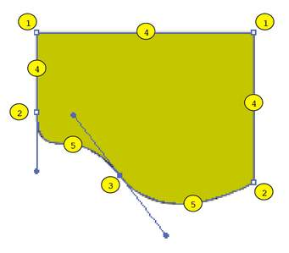

This is also one of the interesting units that is all about text and pictures. We have gotten a chance to draw so many things starting from paper work that we even glued on the wall. We also have used the pen tool in our computer Adobe Illustrator which is interesting and tiresome at the same time.

**4. ENTREPRENEURSHIP**

In Entrepreneurship is all about business. The facilitator is very engaging and friendly, she teaches us giving analogies which are happening in the real world. I find this unit very fun because my dream is to an entrepreneur one day. So far we have learnt the skills of an entrepreneur, types of innovations where we discussed the advantages and disadvantages of each type.

**5. ELECTRONICS**

According to me this is one of the challenging units for me, I have not yet understood some concepts but with time I know I will catch up. In electronics, we have learnt about voltage and current. I hope soon I will learn calculating this arithmetic.

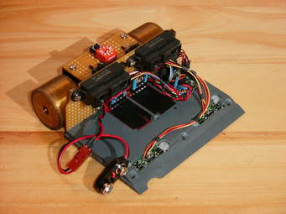

**6. HARDWARE DESIGN**

Hardware design is also an interesting unit where we are taught how products are designed. I am so excited about this because I wish to design one of my own products.

**CONCLUSION**

In conclusion, I would say that the experience so far is fun and interesting.